SIMATSENGINEERING
ASSESSMENTTOOL-2

COURSENAME:COMPUTERNETWORKS COURSE CODE: CSA0708

COURSEOUTCOMECOVERED

CO2:ConfigureIPaddressingschemes, subnetting,andbasicroutingtechniques using simulation tool, for efficient network design and topology. (BL3)
AssessmentTool Weightage: 30%

QUESTIONS:5 TotalMarks:50

AnnexureA

Scenario-Based

CodeofConduct:

I S DHANUSH (192524317) certifythatthissubmissionismyoriginalworkandthatIhave adhered to the guidelines specified for this assessment.
Iunderstandthatanyviolationofacademicintegrityruleswillresultindisciplinary action.

Signatureofthestudent:

S DHANUSH (192524317)

SubnetAllocationforSmart Campus
GivenIPblock:192.168.100.0/24
A/24network contains:
  - Totaladdresses=2³²−2⁴=256
  - Addressrange=192.168.100.0 – 192.168.100.255
Thedepartmentsare assigned/25,/26,and/27.

SchoolofComputing—/25
Subnetmask:255.255.255.128
  - Blocksize=128 addresses
  - Networkaddress=192.168.100.0
  - Broadcastaddress=192.168.100.127
  - Validhostrange=192.168.100.1–192.168.100.126
  - Usablehosts= 128−2=126

SchoolofElectronics—/26
Thenextavailableblockstartsat192.168.100.128. Subnet mask: 255.255.255.192
  - Blocksize=64 addresses
  - Networkaddress=192.168.100.128
  - Broadcastaddress=192.168.100.191
  - Validhostrange=192.168.100.129–192.168.100.190
  - Usablehosts= 64−2=62

SchoolofMechanicalEngineering—/27
Thenextavailableblockstartsat192.168.100.192. Subnet mask: 255.255.255.224
  - Blocksize=32 addresses
  - Networkaddress=192.168.100.192
  - Broadcastaddress=192.168.100.223
  - Validhostrange=192.168.100.193–192.168.100.222
  - Usablehosts= 32−2=30

RemainingUnusedIPAddressRange
The/24blockendsat 192.168.100.255.
TheMechanicalEngineeringsubnetendsat192.168.100.223. Therefore, the remaining unused addresses are:
192.168.100.224– 192.168.100.255
Thisgives32totaladdressesremaining.
Ifthisremaining blockistobeusedasanothersubnet, itcan beallocated as:
  - Networkaddress: 192.168.100.224
  - Broadcastaddress:192.168.100.255
  - Validhostrange:192.168.100.225–192.168.100.254
  - Usablehosts: 30
  - CIDR:/27
AddressAllocationDiagram
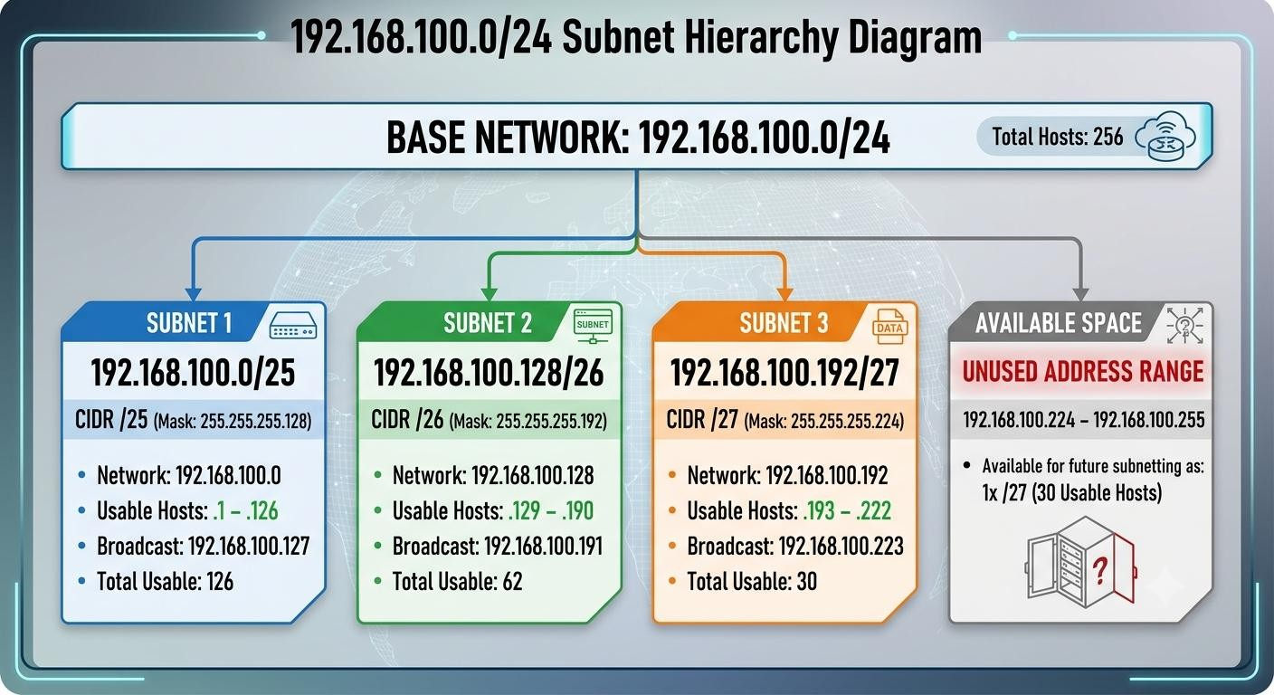
Answer:Thethreedepartmentsrequire218usablehostaddressesintotal(126+62+ 30), and the remaining /27 block from 192.168.100.224/27 is available for future expansion.

SubnetAllocationfortheSoftwareCompany
GivenIPblock:10.10.0.0/16
The/16 block provides:
  - Totaladdresses=2¹⁶=65,536
  - Overallrange=10.10.0.0 – 10.10.255.255
Thesubnetsareallocatedsequentially.

SoftwareDevelopment—/24
A/24subnetcontains 256 addresses.
  - NetworkAddress:10.10.0.0
  - BroadcastAddress:10.10.0.255
  - ValidHostRange:10.10.0.1–10.10.0.254
  - UsableHosts:256−2=254
SubnetMask:255.255.255.0

QualityAssurance—/25
Thenextavailableaddressis10.10.1.0. A /25 subnet contains 128 addresses.
  - NetworkAddress:10.10.1.0
  - BroadcastAddress:10.10.1.127
  - ValidHostRange:10.10.1.1–10.10.1.126
  - UsableHosts:128−2=126
SubnetMask:255.255.255.128

HumanResources—/26
Thenextavailableaddressis10.10.1.128. A /26 subnet contains 64 addresses.
  - NetworkAddress:10.10.1.128
  - BroadcastAddress:10.10.1.191
  - ValidHostRange:10.10.1.129–10.10.1.190
  - UsableHosts:64−2=62
SubnetMask:255.255.255.192

ExecutiveManagement —/27
Thenextavailableaddressis10.10.1.192. A /27 subnet contains 32 addresses.
  - NetworkAddress:10.10.1.192
  - BroadcastAddress:10.10.1.223
  - ValidHostRange:10.10.1.193–10.10.1.222
  - UsableHosts: 32-2=30
SubnetMask:255.255.255.224

UnusedIPAddressRange
TheExecutiveManagementsubnetendsat:
10.10.1.223
Theoriginal /16 block endsat:
10.10.255.255
Therefore,theremainingunusedIPaddressrangeis:
10.10.1.224– 10.10.255.255
Thisrepresents65,056unusedaddresses. The first unused portion is:
10.10.1.224– 10.10.1.255
followedbytheentirerange:
10.10.2.0– 10.10.255.255
AddressAllocationDiagram:
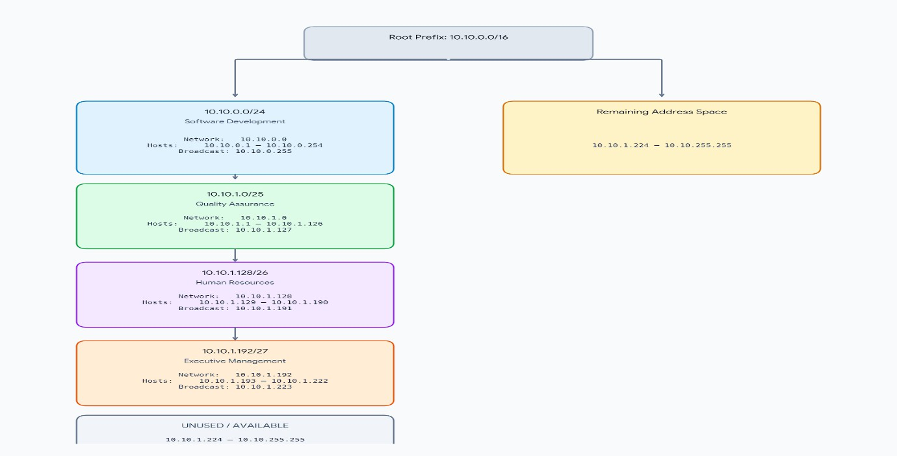

Totalusablehostsallocated:
254 +126 +62+30=472hosts

Totalunusedaddresses:65,056addresses.

IPv6 Subnet Calculation – Smart Hospital Given IPv6 network: 2001:0db8:abcd:0000:0000:0000:0000:0000/64
AnIPv6addresshas128 bits,dividedintoeight16-bithexadecimalgroups.

CompressedNotation
Given: 2001:0db8:abcd:0000:0000:0000:0000:0000/64
Theconsecutivegroupsofzeroscanbereplacedby::. Therefore:

CompressedIPv6Address
2001:db8:abcd::/64
- ExpandtheCompressedAddress Compressed address: 2001:db8:abcd::/64
Therearethreeexplicitlywrittengroups: 2001 : db8 : abcd
The::representstheremainingfivegroupsofzeros. Therefore, the full hexadecimal representation is: 2001:0db8:abcd:0000:0000:0000:0000:0000/64

IdentifytheNetwork Prefix
Theprefixlengthis/64. This means:
  - First64bits=Networkportion
  - Remaining 64 bits = Interface/host portion Thefirstfour16-bitgroupsformthenetworkprefix: 2001:0db8:abcd:0000

Therefore,thenetworkprefixis:
2001:0db8:abcd:0000/64 or, in compressed form: 2001:db8:abcd::/64

Calculatethe Numberof HostAddresses
IPv6has128bits. Given prefix:
/64
Host bits:

Therefore:
128−64=64

264

Sothenumberofpossiblehostaddressesis:
18,446,744,073,709,551,616

TotalPossibleHostAddresses
The/64 subnet contains:

18,446,744,073,709,551,616 possible addresses
UnlikeIPv4,IPv6doesnotsubtracttwoaddressesfornetworkandbroadcastaddresses in the usual subnet calculation, because IPv6 has no broadcast address.
FinalAnswer

Requirement | Answer
GivenIPv6 | 2001:0db8:abcd:0000:0000:0000:0000:0000/64
Compressed notation | 2001:db8:abcd::/64
Expandednotation | 2001:0db8:abcd:0000:0000:0000:0000:0000/64
Networkprefix | 2001:0db8:abcd:0000/64
Networkbits | 64 bits
Host/interfacebits | 64 bits
Totaladdresses | 2⁶⁴
Totalpossibleaddresses | 18,446,744,073,709,551,616

Simple Diagram:

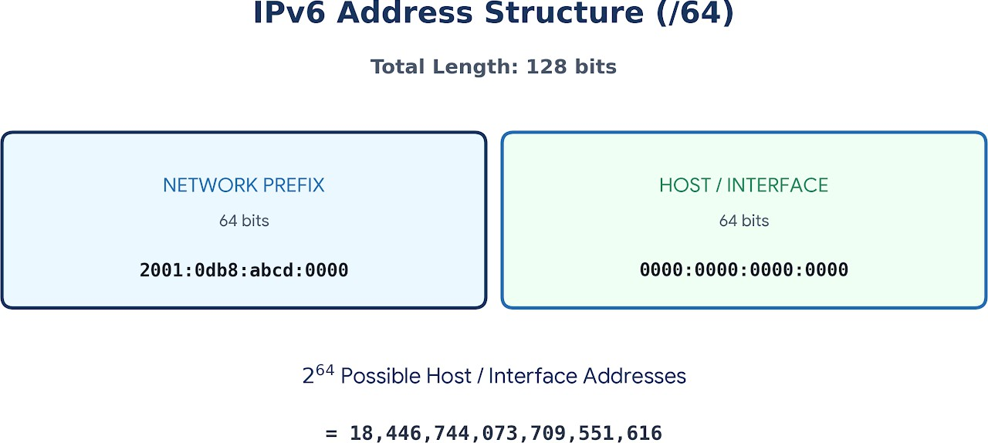

RoutingTableLookup
Givenroutingtable:
192.168.1.0/24
192.168.2.0/24
192.168.3.0/24
DestinationIP:
192.168.2.45

DestinationSubnet
The/24maskmeansthefirstthreeoctetsidentifythenetwork. Destination IP:192.168.2.45
Subnetmask: 255.255.255.0
─────────────
Network: 192.168.2.0
Therefore,thedestinationbelongsto:
192.168.2.0/24

MatchingRoutingTableEntry
Comparethedestinationwith therouting table:

RoutingEntry | Match?
192.168.1.0/24 | +No
192.168.2.0/24 | ⬛Yes
192.168.3.0/24 | +No

Sothe matchingentry is:
192.168.2.0/24

Next-HopNetwork/Interface
Therouter forwardsthepackettowardtheinterfaceconnectedto:
192.168.2.0/24
Theexactnext-hopIP/interfaceisnotprovidedinthequestion,soitcannotbe determined numerically.
For example:
Destination: 192.168.2.45
↓
Routerchecksroutingtable
↓
Matches192.168.2.0/24
↓
Forwardthroughinterfaceconnected to 192.168.2.0/24

Default Route
Ifthedestinationdoesnotmatchanyspecificrouting-tableentry,therouterusesa default route:
0.0.0.0/0
Thedefaultroutemeans anyIPv4destinationthathasnomore-specificmatching route.
FinalAnswers

Question | Answer
DestinationIP | 192.168.2.45
Destination subnet | 192.168.2.0/24
Matchingentry | 192.168.2.0/24

Next-hop/interface | Interfaceconnectedto 192.168.2.0/24
Defaultroute | 0.0.0.0/0

Simple Routing Diagram
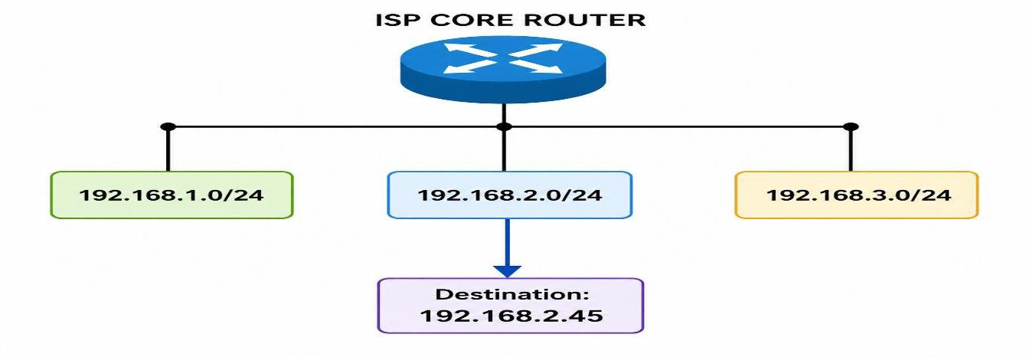
Conclusion:Since192.168.2.45fallswithin192.168.2.0/24,therouterselectsthat routing-table entry and forwards the packet through the interface connected to that subnet. If no route matches, it uses 0.0.0.0/0.

Layer-3Router–LANIPAddressing
Given:
  - AdministrationLAN:192.168.10.0/26
  - FinanceLAN:192.168.10.64/26
  - AdministrationGateway:192.168.10.1
  - FinanceGateway:192.168.10.65
A/26subnethas64totaladdressesand62usablehostaddresses.
- Administration LAN Network:192.168.10.0/26
  - Networkaddress: 192.168.10.0
  - Broadcastaddress:192.168.10.63
  - Validhostrange:192.168.10.1–192.168.10.62
  - Defaultgateway:192.168.10.1

ThreesuitablecomputerIPs

Computer | IPAddress | DefaultGateway
Computer1 | 192.168.10.2 | 192.168.10.1
Computer2 | 192.168.10.3 | 192.168.10.1
Computer3 | 192.168.10.4 | 192.168.10.1

Finance LAN
Network:192.168.10.64/26
  - Networkaddress: 192.168.10.64
  - Broadcastaddress:192.168.10.127
  - Validhostrange:192.168.10.65–192.168.10.126
  - Defaultgateway:192.168.10.65
Threesuitable computer IPs

Computer | IPAddress | DefaultGateway
Computer1 | 192.168.10.66 | 192.168.10.65
Computer2 | 192.168.10.67 | 192.168.10.65
Computer3 | 192.168.10.68 | 192.168.10.65

FinalAnswer

LAN | Net wor k Add  ress | Valid Host Rang e | Broa dcast | Gat ewa y
Admini stratio n | 192.1  68.10  .0 | 192.16  8.10.1 – 192.16  8.10.6  2 | 192.16  8.10.6  3 | 192.1  68.10  .1
Financ e | 192.1  68.10  .64 | 192.16  8.10.6  5–  192.16  8.10.1  26 | 192.16  8.10.1  27 | 192.1  68.10  .65

NetworkDiagram:
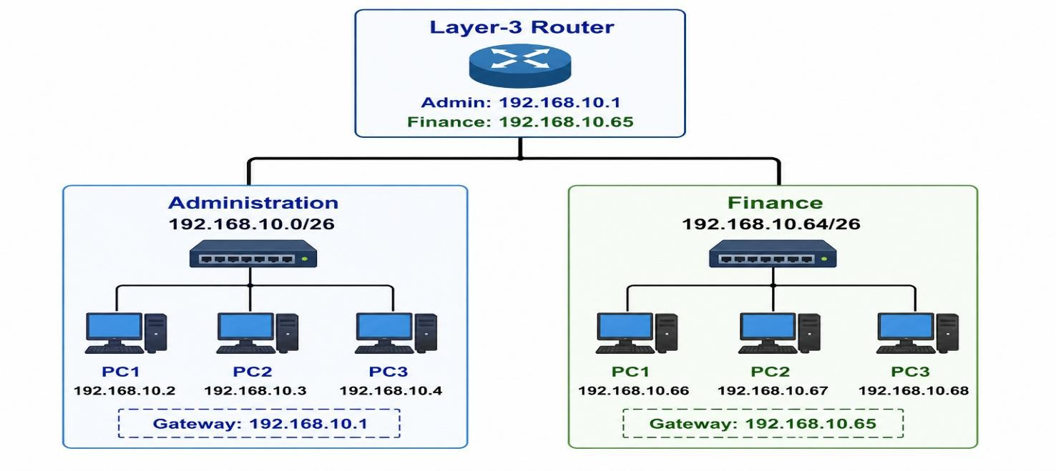
Keypoint:HostsintheAdministrationLANuse192.168.10.1astheirdefaultgateway, while hosts in the Finance LAN use 192.168.10.65.

